SIMATS ENGINEERING
ASSESSMENT TOOL 1
NAME: Danuspriyaa
REG NO: 192411182
COURSE NAME: INTERNET PROGRAMMING
COURSE CODE: CSA43

COURSE OUTCOME COVERED
CO-2 : Apply CSS layout and styling techniques to create visually appealing and responsive
web interfaces, and use JavaScript to enable interactive client-side behavior. (L3)
Assessment Tool : Integrated Experiments
Weightage: 40%

QUESTIONS: Total Marks: 30

Experiment 1: Responsive Layout Design
Suppose that a retail website is not responsive across mobile and tablet devices, causing
misalignment of content and improper spacing.
(a) Analyze the possible reasons for lack of responsiveness in the existing layout.
(b) Design a responsive webpage layout using CSS Flexbox or Grid, ensuring proper
alignment of header, navigation, content, and footer.
(c) Demonstrate how the layout adapts to different screen sizes (mobile, tablet, desktop)
using media queries.
(d) Implement spacing, alignment, and distribution techniques to improve visual consistency.
(e) Evaluate the effectiveness of the responsive design and suggest further improvements.

<!DOCTYPE html>
<html lang="en">
<head>
<meta charset="UTF-8">
<meta name="viewport" content="width=device-width, initial-scale=1.0">
<title>Responsive Layout Design</title>

<style>
*{
margin:0;
padding:0;
box-sizing:border-box;
font-family:Arial,sans-serif;
}

body{
background:#f4f4f4;
}

/* Header */
header{
background:#0077cc;
color:white;
padding:20px;
text-align:center;
}

/* Navigation */
nav{
background:#333;
}

nav ul{
display:flex;
justify-content:center;
list-style:none;
flex-wrap:wrap;
}

nav ul li{
padding:15px 20px;
}

nav ul li a{
color:white;
text-decoration:none;
font-weight:bold;
}

/* Main Container */
.container{
display:flex;
gap:20px;
padding:20px;
}

/* Content */
.content{
flex:3;
background:white;
padding:20px;
border-radius:10px;
}

/* Sidebar */
.sidebar{
flex:1;
background:#e8e8e8;
padding:20px;
border-radius:10px;
}

/* Footer */
footer{
background:#222;
color:white;
text-align:center;
padding:15px;
margin-top:20px;
}

/* Tablet View */
@media(max-width:768px){
.container{
flex-direction:column;
}

nav ul{
justify-content:space-around;
}
}

/* Mobile View */
@media(max-width:480px){

header{
font-size:18px;
}

nav ul{
flex-direction:column;
text-align:center;
}

nav ul li{
border-bottom:1px solid white;
}

.container{
padding:10px;
}

.content,
.sidebar{
padding:15px;
}
}
</style>

</head>
<body>

<header>
<h1>Retail Website</h1>
<p>Responsive Layout Using CSS Flexbox</p>
</header>

<nav>
<ul>
<li><a href="#">Home</a></li>
<li><a href="#">Products</a></li>
<li><a href="#">Offers</a></li>
<li><a href="#">About</a></li>
<li><a href="#">Contact</a></li>
</ul>
</nav>

<div class="container">

<div class="content">
<h2>Main Content</h2>
<br>

<p>
Welcome to our retail website. This page automatically adjusts its layout
based on screen size.
</p>

<br>

<p>
On desktop screens, the content and sidebar appear side by side.
On tablets and mobile devices, they are stacked vertically for better readability.
</p>

<br>

<p>
CSS Flexbox and Media Queries are used to create this responsive design.
</p>

</div>

<div class="sidebar">
<h2>Sidebar</h2>
<br>

<ul>
<li>Latest Products</li>
<li>Special Offers</li>
<li>Top Categories</li>
<li>Customer Support</li>
</ul>

</div>

</div>

<footer>
<p>© 2026 Retail Website | Responsive Web Design Experiment</p>
</footer>

</body>
</html>
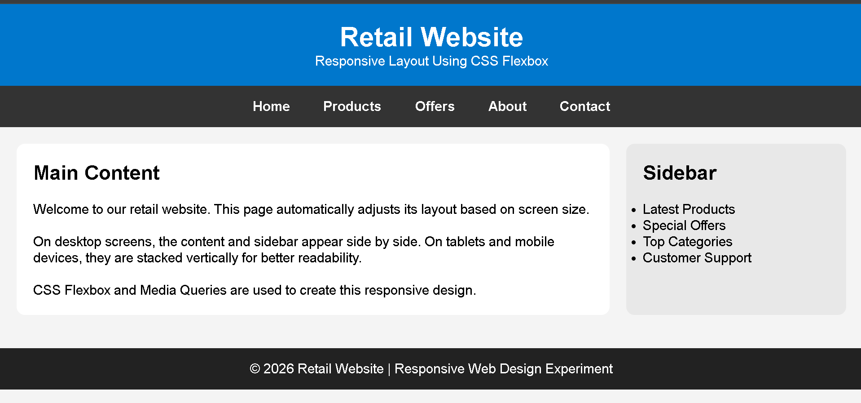

Experiment 2: Form Validation using JavaScript
Suppose that a registration form accepts invalid email and phone number inputs, leading to
incorrect data submission.
(a) Analyze the issues in the existing form validation mechanism.
(b) Design input fields for email and phone number with appropriate HTML attributes.
(c) Implement JavaScript validation using Regular Expressions for both email and phone
number.

(d) Develop a mechanism to display real-time error messages for invalid inputs.
(e) Evaluate the validation system and suggest enhancements for better user experience and
security.
<!DOCTYPE html>
<html lang="en">
<head>
<meta charset="UTF-8">
<meta name="viewport" content="width=device-width, initial-scale=1.0">
<title>Experiment 2 - Form Validation</title>

<style>
*{
margin:0;
padding:0;
box-sizing:border-box;
font-family:Arial,sans-serif;
}

body{
background:#f2f2f2;
display:flex;
justify-content:center;
align-items:center;
height:100vh;
}

.container{
width:350px;
background:white;
padding:25px;
border-radius:10px;
box-shadow:0 0 10px rgba(0,0,0,0.2);
}

h2{
text-align:center;
margin-bottom:20px;
color:#333;
}

label{
font-weight:bold;
}

input{
width:100%;
padding:10px;
margin-top:5px;
margin-bottom:5px;
border:1px solid #999;
border-radius:5px;
font-size:15px;
}

input:focus{
border-color:#007BFF;
outline:none;
}

.error{
color:red;
font-size:13px;
margin-bottom:10px;
}

.success{
color:green;
font-size:14px;
text-align:center;
margin-top:10px;
}

button{
width:100%;
padding:10px;
background:#007BFF;
color:white;
border:none;
border-radius:5px;
font-size:16px;
cursor:pointer;
}

button:hover{
background:#0056b3;
}
</style>

</head>

<body>

<div class="container">

<h2>Registration Form</h2>

<form id="myForm">

<label>Email</label>
<input
type="email"
id="email"
placeholder="Enter Email"
required
>

<div id="emailError" class="error"></div>

<label>Phone Number</label>
<input
type="tel"
id="phone"
placeholder="Enter 10-digit Phone Number"
maxlength="10"
required
>

<div id="phoneError" class="error"></div>

<button type="submit">Register</button>

<div id="successMessage" class="success"></div>

</form>

</div>

<script>

const email=document.getElementById("email");
const phone=document.getElementById("phone");

const emailError=document.getElementById("emailError");
const phoneError=document.getElementById("phoneError");
const success=document.getElementById("successMessage");

const emailPattern=/^[^\s@]+@[^\s@]+\.[^\s@]+$/;
const phonePattern=/^[6-9]\d{9}$/;

email.addEventListener("input",function(){

if(emailPattern.test(email.value)){
emailError.innerHTML="";
}
else{
emailError.innerHTML="Enter a valid email address.";
}

});

phone.addEventListener("input",function(){

if(phonePattern.test(phone.value)){
phoneError.innerHTML="";
}
else{
phoneError.innerHTML="Enter a valid 10-digit phone number.";
}

});

document.getElementById("myForm").addEventListener("submit",function(event){

event.preventDefault();

let valid=true;

if(!emailPattern.test(email.value)){
emailError.innerHTML="Invalid email format.";
valid=false;
}
else{
emailError.innerHTML="";
}

if(!phonePattern.test(phone.value)){
phoneError.innerHTML="Invalid phone number.";
valid=false;
}
else{
phoneError.innerHTML="";
}

if(valid){
success.innerHTML="Registration Successful!";
}
else{
success.innerHTML="";
}

});

</script>

</body>
</html>
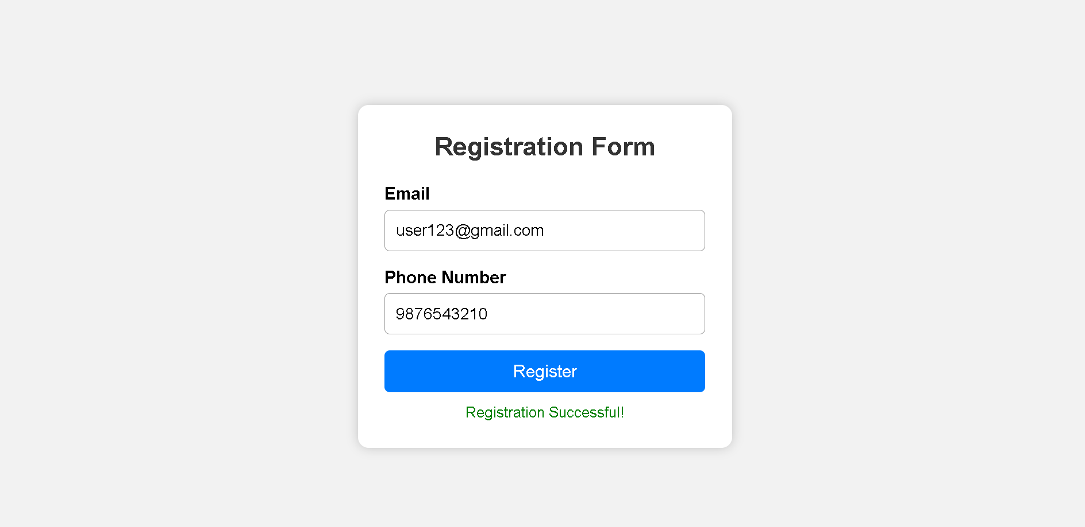
Experiment 3: CSS Layout Debugging
Suppose that a webpage layout overlaps when the browser window is resized, affecting
usability.
(a) Analyze the CSS properties responsible for layout overlapping issues.
(b) Examine the role of the CSS box model (margin, border, padding, content) in layout
design.
(c) Debug the layout using appropriate positioning techniques (relative, absolute, flex,
grid).
(d) Modify the CSS to ensure proper alignment and prevent overlapping during resizing.
(e) Evaluate the corrected layout and suggest best practices for maintaining consistency.
<!DOCTYPE html>
<html lang="en">
<head>
<meta charset="UTF-8">
<meta name="viewport" content="width=device-width, initial-scale=1.0">
<title>Experiment 3 - CSS Layout Debugging</title>

<style>
*{
margin:0;
padding:0;
box-sizing:border-box;
font-family:Arial, sans-serif;
}

body{
background:#f4f4f4;
line-height:1.6;
}

/* Header */
header{
background:#2196F3;
color:white;
text-align:center;
padding:20px;
}

/* Navigation */
nav{
background:#333;
}

nav ul{
display:flex;
justify-content:center;
list-style:none;
flex-wrap:wrap;
}

nav ul li{
padding:15px 20px;
}

nav ul li a{
color:white;
text-decoration:none;
font-weight:bold;
}

nav ul li:hover{
background:#555;
}

/* Main Layout */
.container{
display:flex;
gap:20px;
padding:20px;
}

/* Content */
.content{
flex:3;
background:white;
padding:20px;
border-radius:10px;
box-shadow:0 0 8px rgba(0,0,0,0.2);
}

/* Sidebar */
.sidebar{
flex:1;
background:#e8e8e8;
padding:20px;
border-radius:10px;
box-shadow:0 0 8px rgba(0,0,0,0.2);
}

/* Footer */
footer{
background:#222;
color:white;
text-align:center;
padding:15px;
margin-top:20px;
}

/* Tablet View */
@media (max-width:768px){

.container{
flex-direction:column;
}

}

/* Mobile View */
@media (max-width:480px){

header{
font-size:18px;
}

nav ul{
flex-direction:column;
}

nav ul li{
text-align:center;
border-bottom:1px solid white;
}

.container{
padding:10px;
}

}
</style>

</head>

<body>

<header>
<h1>CSS Layout Debugging</h1>
<p>Responsive Webpage Using Flexbox</p>
</header>

<nav>
<ul>
<li><a href="#">Home</a></li>
<li><a href="#">About</a></li>
<li><a href="#">Services</a></li>
<li><a href="#">Gallery</a></li>
<li><a href="#">Contact</a></li>
</ul>
</nav>

<div class="container">

<div class="content">
<h2>Main Content</h2>

<p>
This webpage demonstrates a responsive layout using CSS Flexbox.
The content automatically adjusts according to the screen size.
</p>

<br>

<p>
The layout prevents overlapping by using flexible widths,
proper spacing, and media queries. Resize the browser window
to observe the responsive behavior.
</p>

<br>

<p>
Flexbox ensures that the content and sidebar remain aligned
without overlapping on desktop, tablet, and mobile devices.
</p>

</div>

<div class="sidebar">

<h2>Sidebar</h2>

<ul>
<li>Latest News</li>
<li>Upcoming Events</li>
<li>Quick Links</li>
<li>Support</li>
</ul>

</div>

</div>

<footer>
<p>© 2026 CSS Layout Debugging Experiment</p>
</footer>

</body>
</html>
